A Banyule Social Story

My day at Community Fun Day – A Celebration of International Day of People with Disability

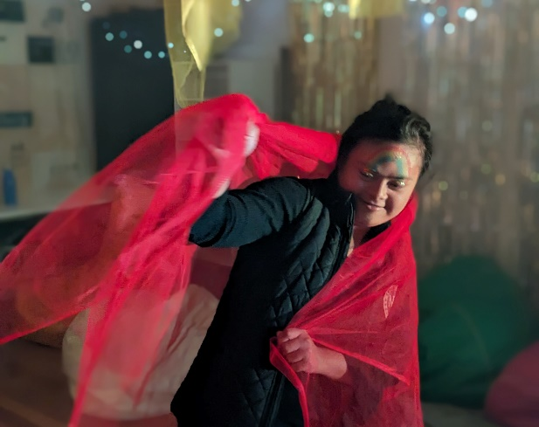

This book belongs to

______________________________

On Tuesday, I am going to Community Fun Day.   
It is at Ivanhoe Library & Cultural Hub.

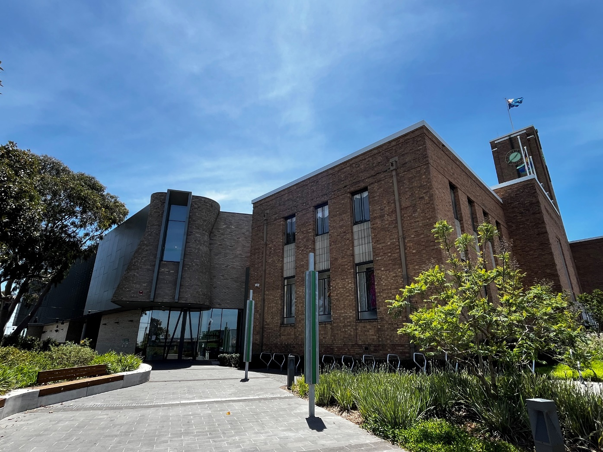

I can enter through the gold doors at the front of the building.

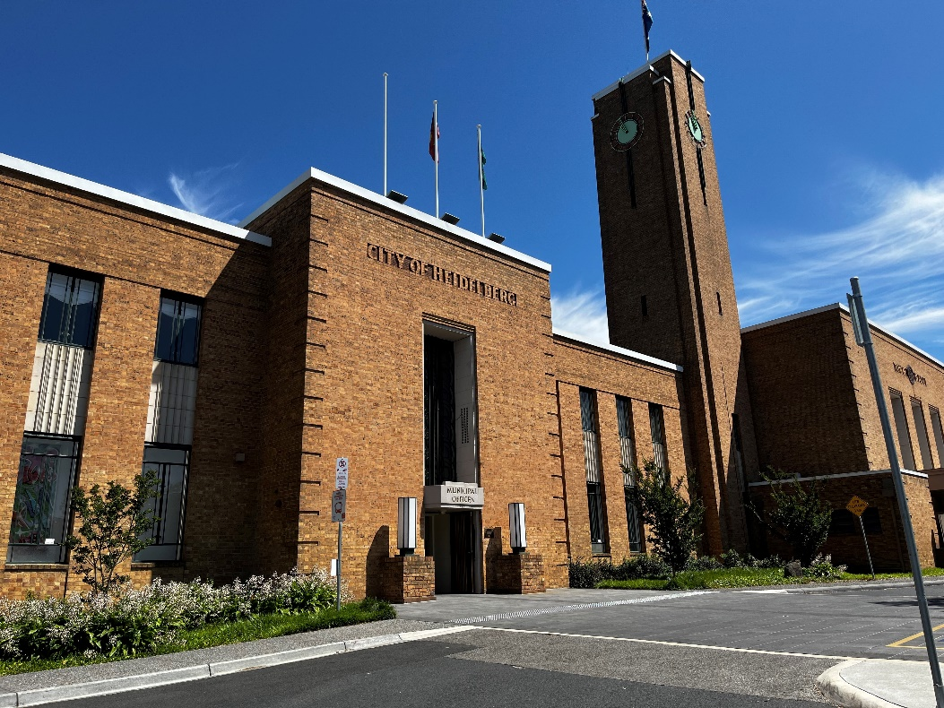 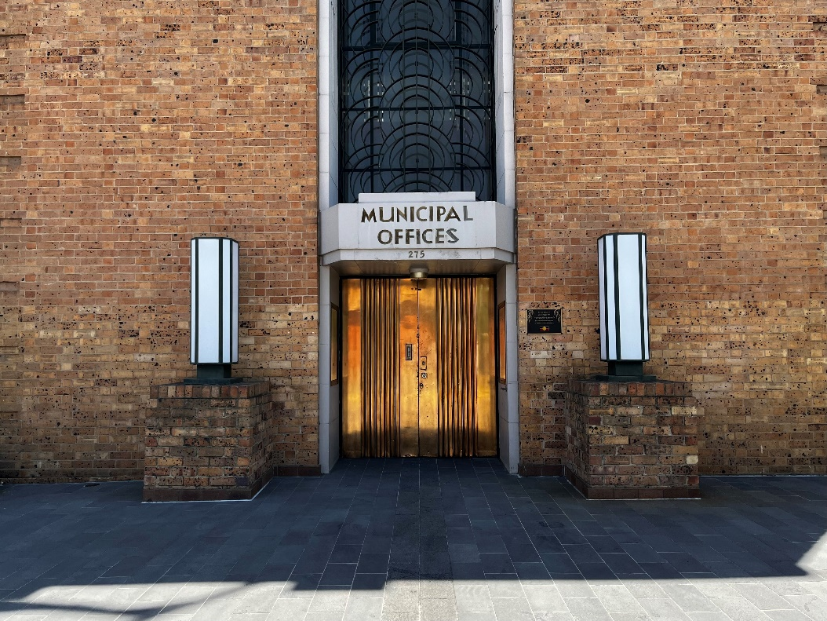

There will be art, poetry, and short films.

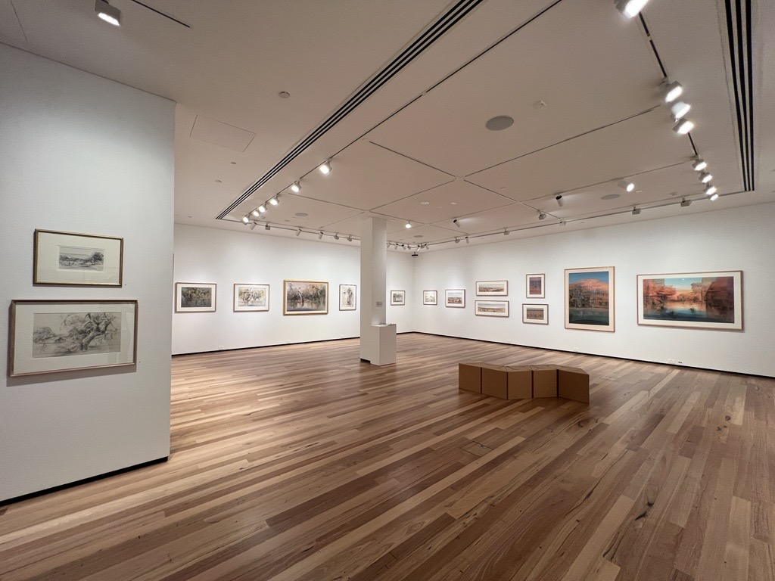

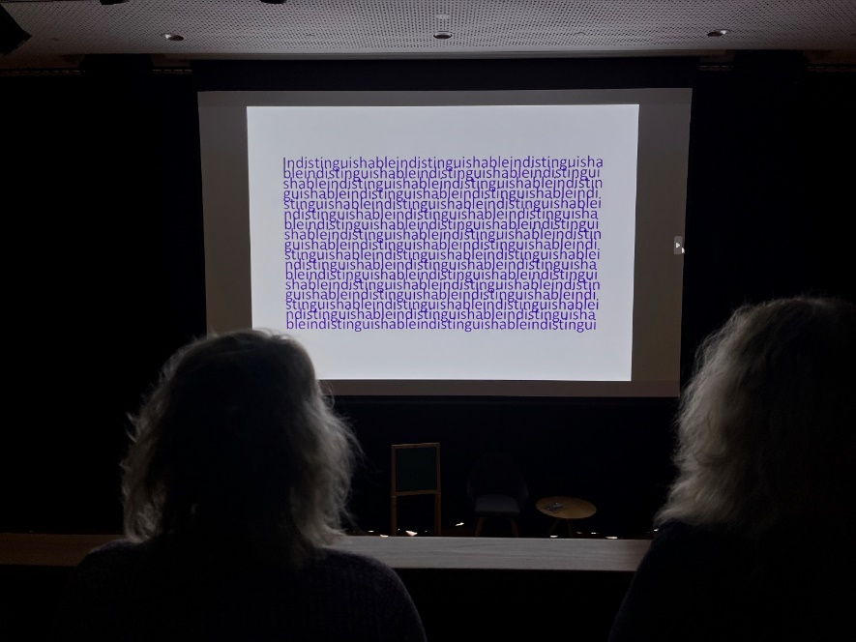

There will be Lego building, puzzles, and group art activities.

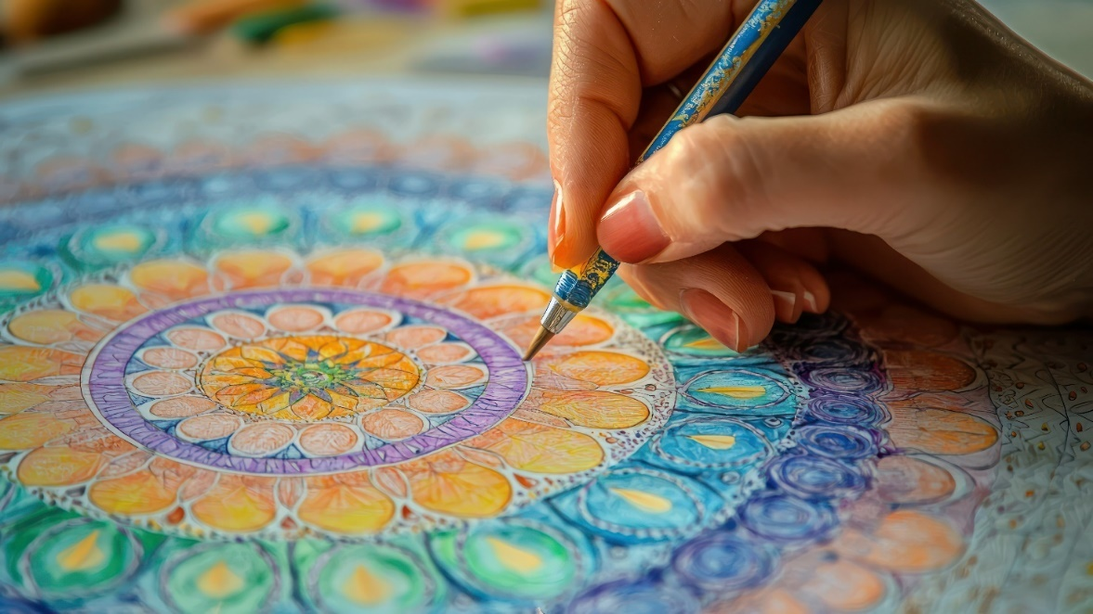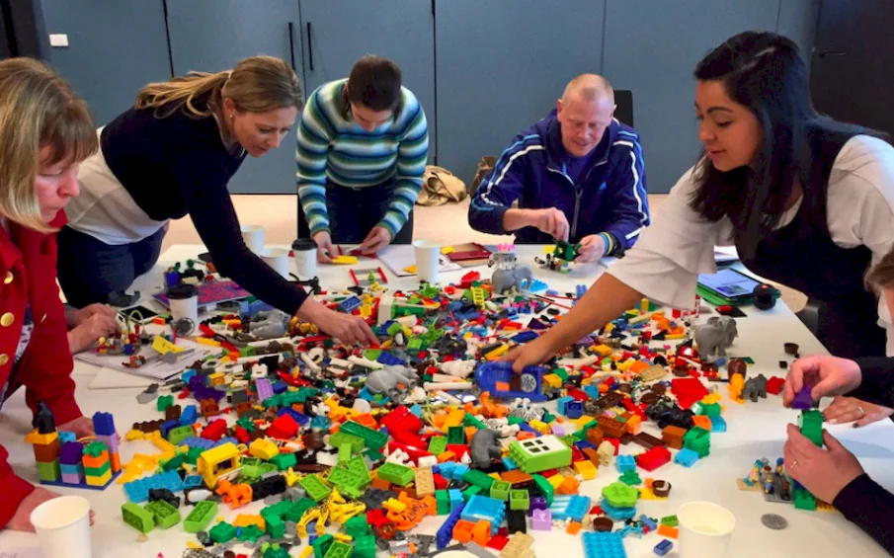

There will DJs playing music! I can use headphones to listen as loud or as quietly as I like.

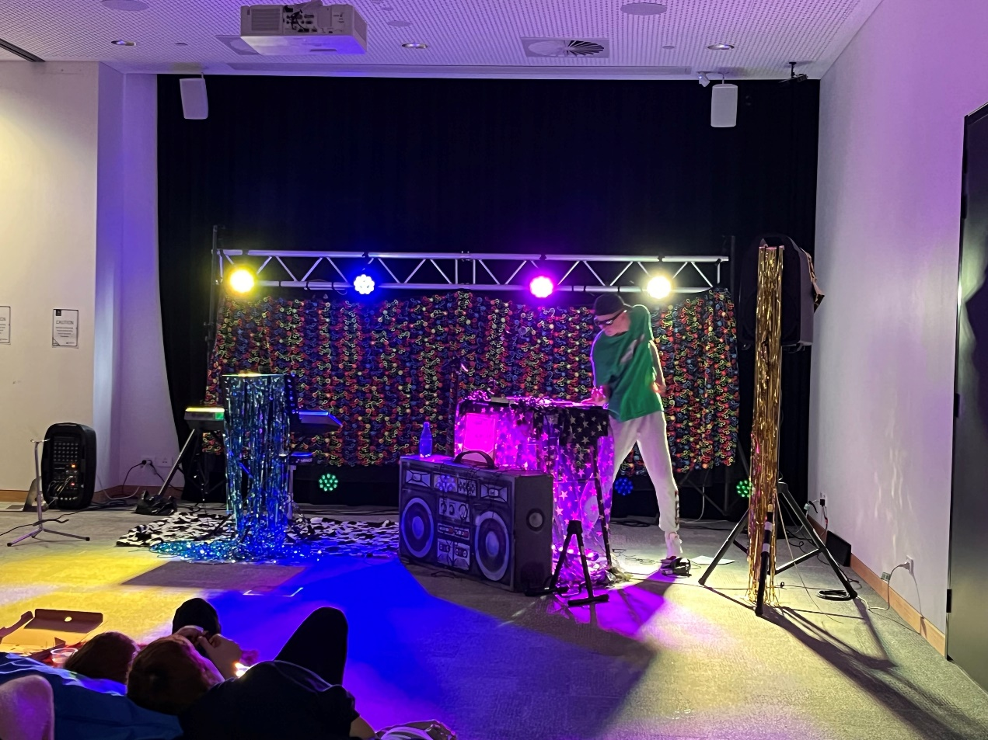

If the noise and people get too loud, I can cover my ears,  
wear earmuffs or wear noise cancelling headphones.

If I feel like I need to sit and rest in a quiet space, I can go to the Chillout Space and relax.

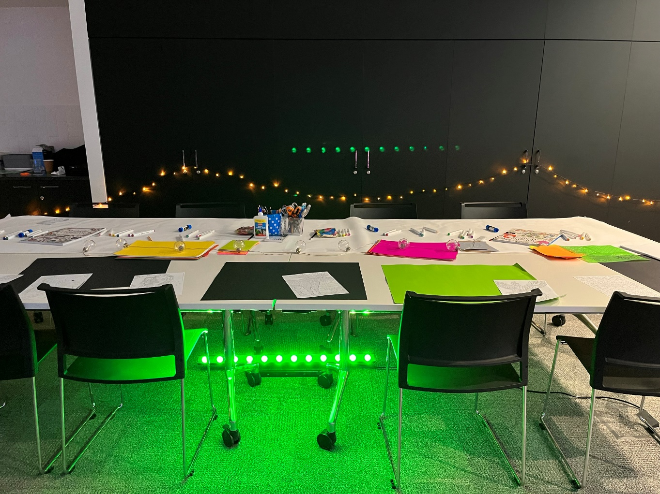

If I need to go to the toilet, there are three available.   
The closest one is here.

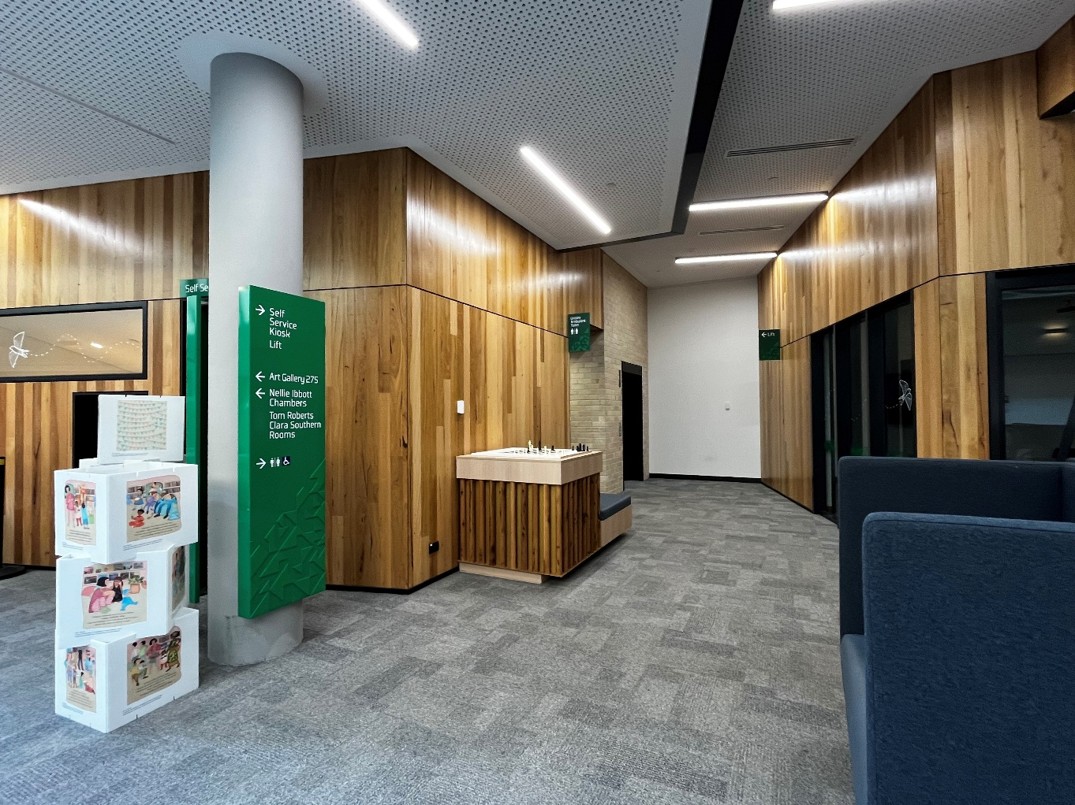

If I am hungry there is a café that sells food and drinks.

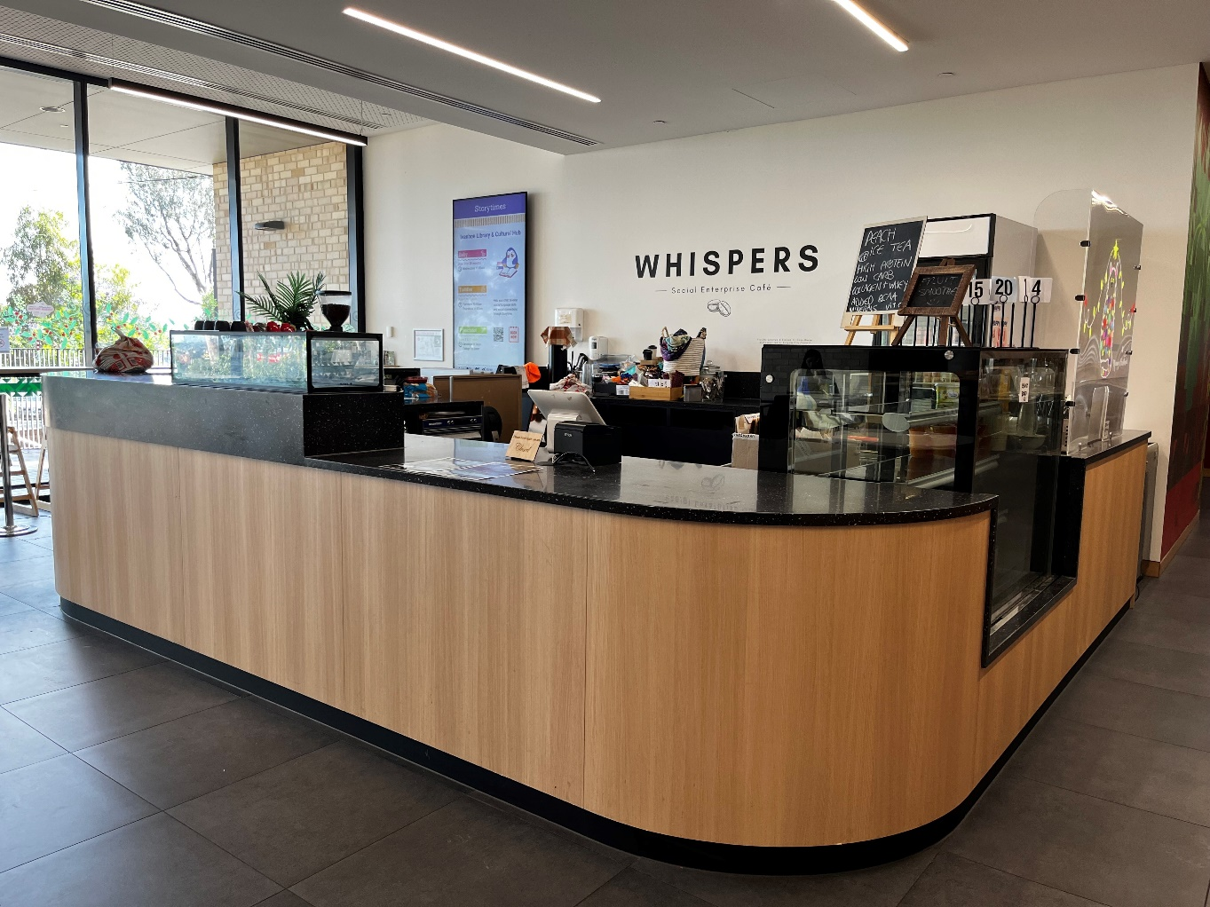

The building is cool and has seats and tables for me to use.

The building has three levels and includes the library with books for me to look at and activity rooms for me to do fun things. I can get to the other levels using a lift or the stairs.

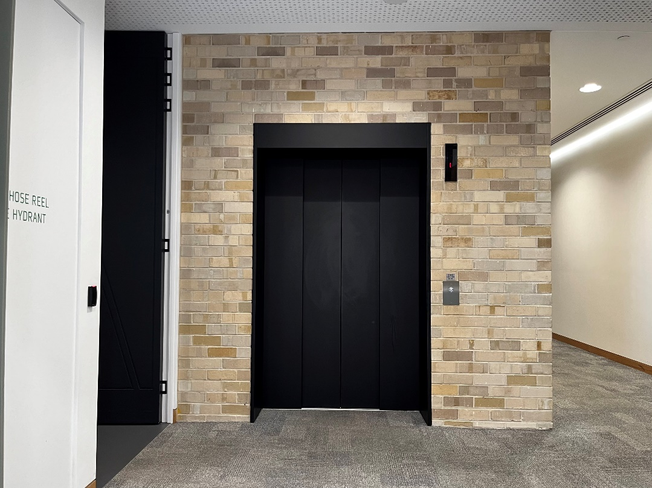

If I need help, I can ask staff at Ivanhoe Library & Cultural Hub. Staff will be wearing a lanyard and name tag.

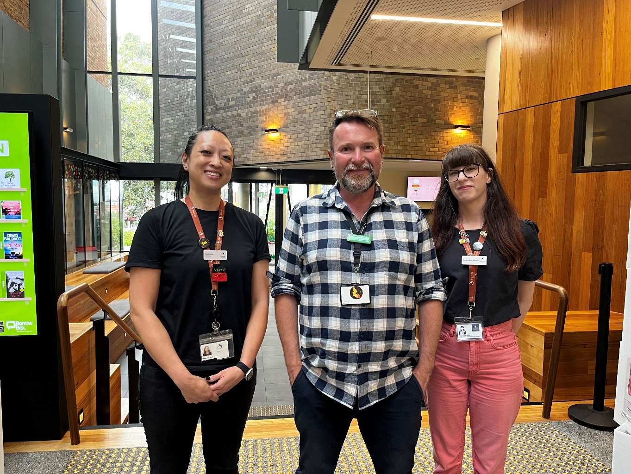

Going to Community Fun Day will be fun!

