A Banyule Social Story

Being part of a Council Advisory Committee



This book belongs to

______________________________

About the Committee



A committee is a group of people who help make Banyule a better place for everyone.

There are five Advisory Committees at Council

1. Connected Communities



This committee helps make Banyule a welcoming and fair place for everyone

1. Arts and Culture



This committee helps grow art, events, music, theatre, culture and heritage in Banyule.

1. Environment and Climate Action



This committee helps protect Banyule’s environment and fight climate change.

1. First Nations



This committee supports and strengthens connection, equity and inclusion of First Nations People

1. Sustainable Living



This committee will give advice on how to make our streets, parks, transport and buildings more welcoming and accessible for everyone

There are four to six committee meetings in a year.



Members will get an invitation for each of these meetings. Meetings will be at Council Offices.

Meetings are a safe place to share your ideas with others



You will be invited to speak and listen to others ideas.

There will be an agenda provided before the meeting to help everyone know what will be discussed



This agenda can be in Easy English

You can ask for help if you need support before, during or after the meeting



Paperwork, notes or a presentation may be provided to help understand the topics



This information can be in Easy English

You can bring a support person if it helps you feel comfortable



You can ask for specific adjustments or things that will make it easier for you in the meeting

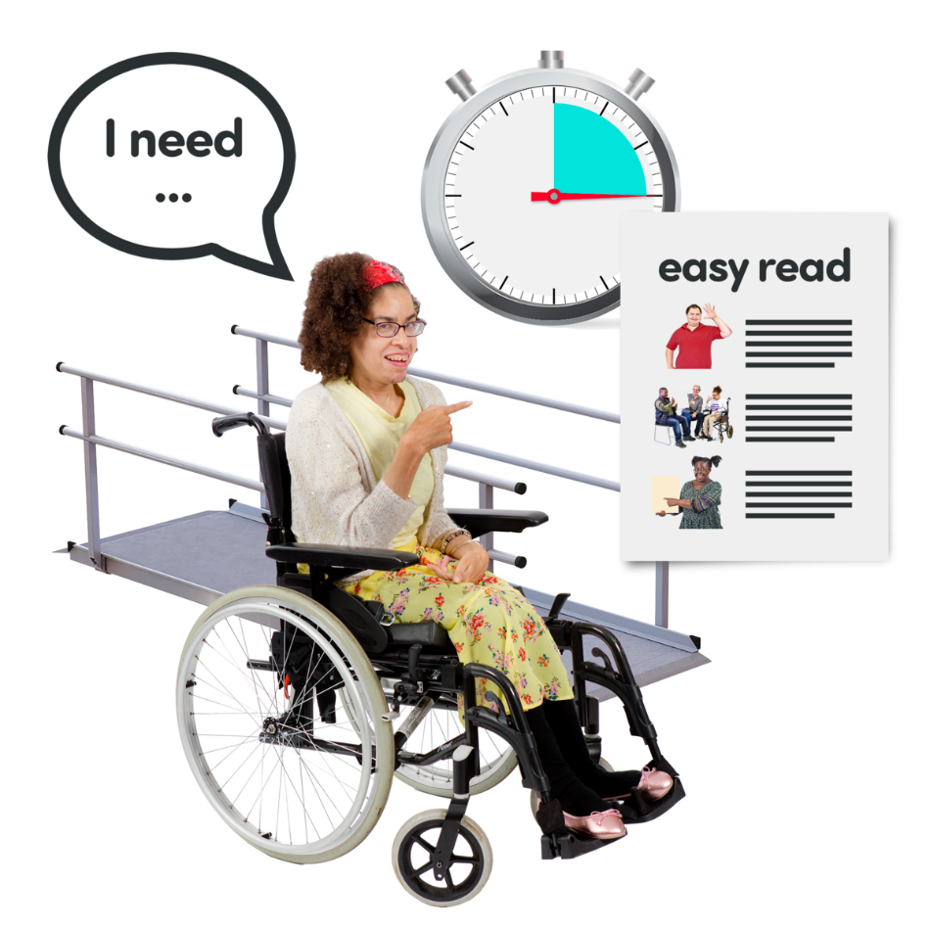

The meeting will be held at Council Offices.

The rooms have a large table, comfortable chairs and there will be bright lights and a projector display.

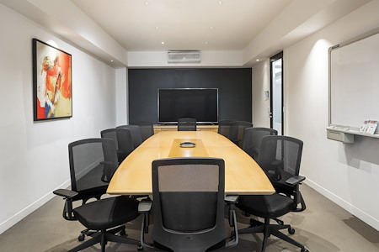

Some rooms can feel cramped, but you can sit near the door.

Meetings follow a structure and everyone gets a chance to speak



Sound: There will be typing and clicking sounds and people talking

There will be breaks if needed to help you stay focused and comfortable



Smells: Coffee and food smells may be there during the breaks

After the meeting you will get notes to remember what was discussed.



These notes can be in Easy English

If you want to be involve in a committee, you can join a committee by filling in a simple form.



If you want assistance filling the form, you can contact Sherryn Prinzi on 03 9457 9908 or [sherryn.prinzi@banyule.vic.gov.au](mailto:sherryn.prinzi@banyule.vic.gov.au)



Applications will be reviewed and selected members are invited to join.



If you are chosen, you will get information about the meetings and what to expect.



If you are not chosen, you could be invited to join the Champions Group or working group. These groups are more casual and will allow you to meet other people who want to make Banyule better

