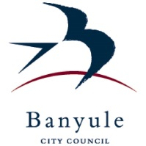

A Banyule Social Story

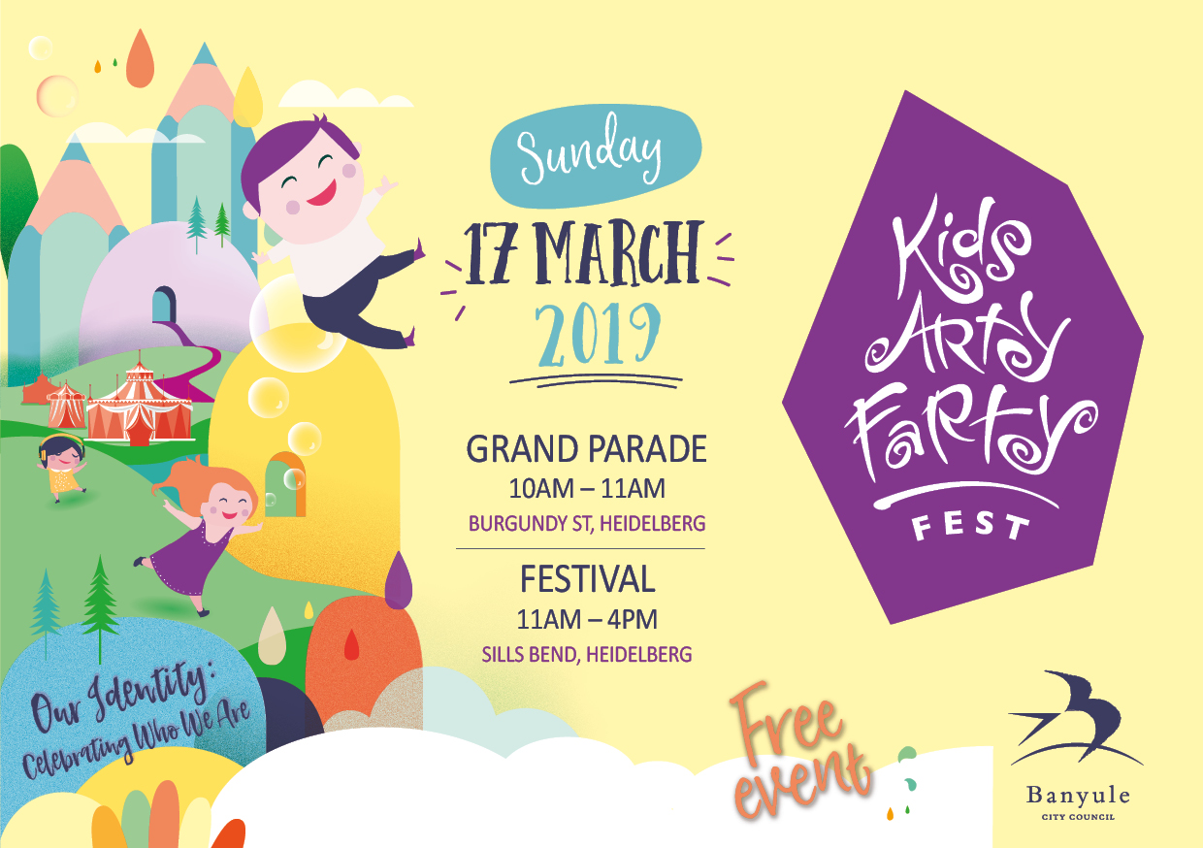My day at the Kids ArtyFarty Fest

This book belongs to

___________________________
I am going to The Kids ArtyFarty Fest on Sunday 17 March, 11am – 4pm.
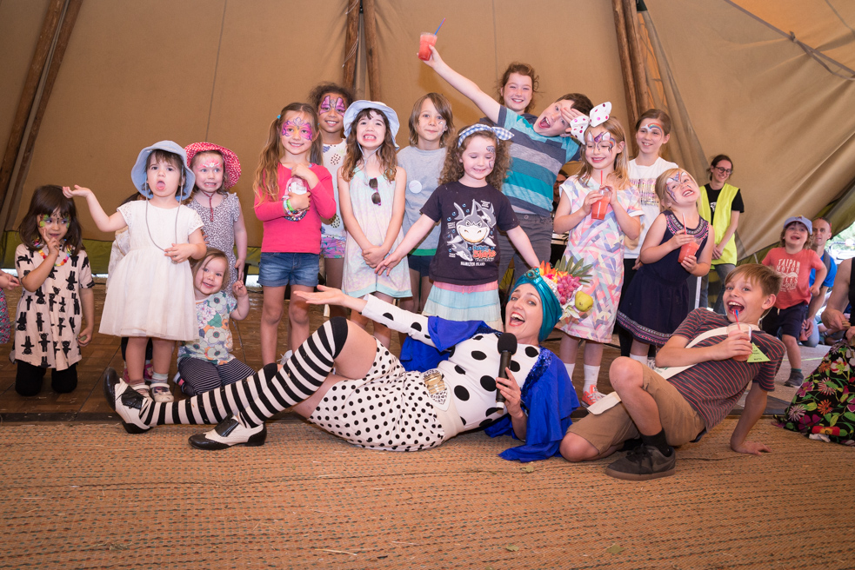

It’s at Sills Bend, which is a large park in Heidelberg.
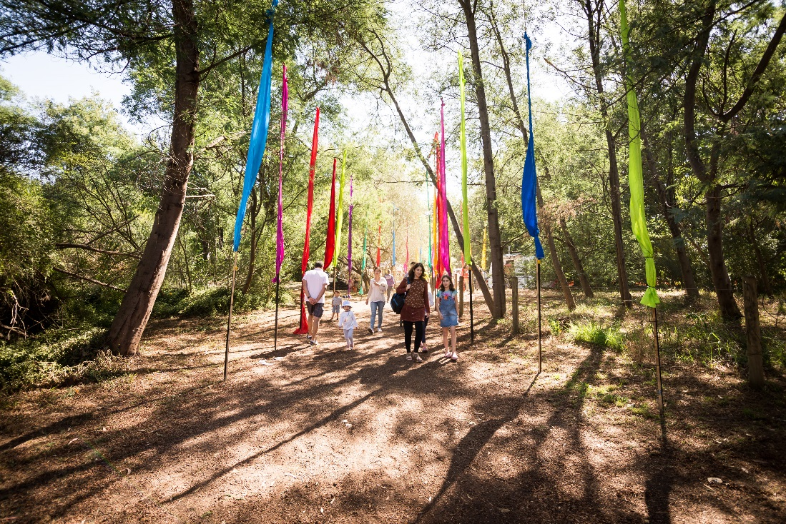

This map shows where everything will be.
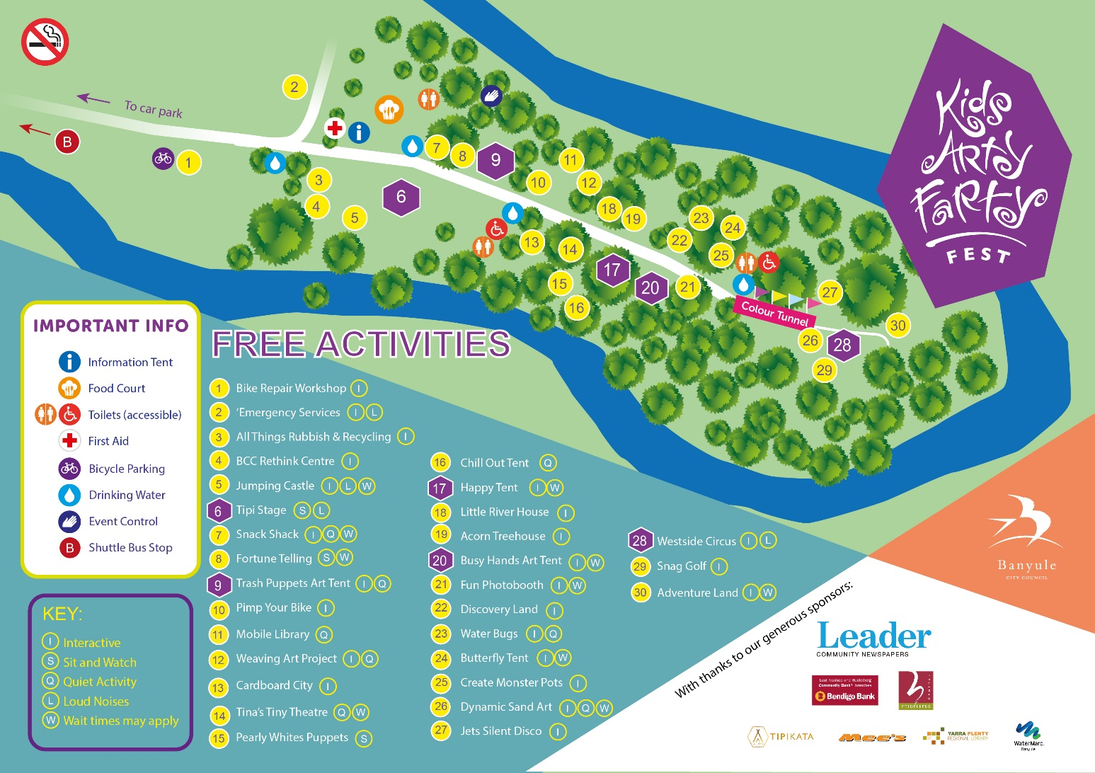

There will be a parade that I can watch. There will be people dressed up, they are just pretending to be a character.
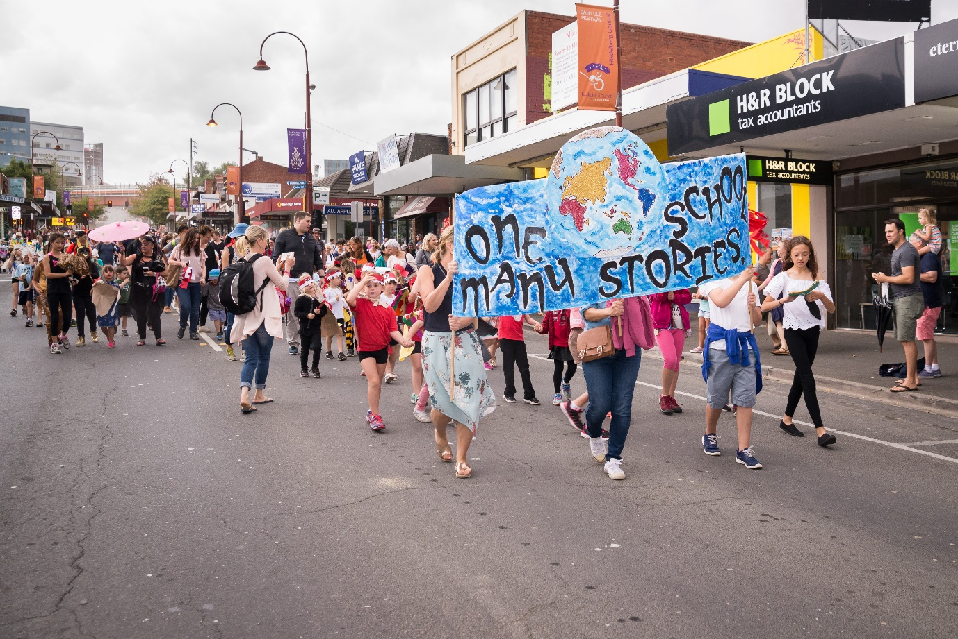

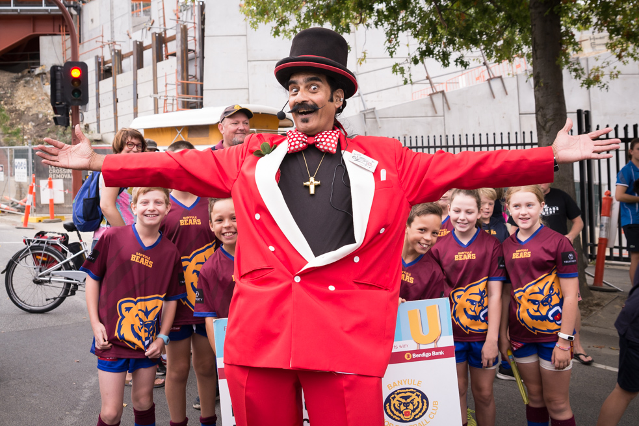
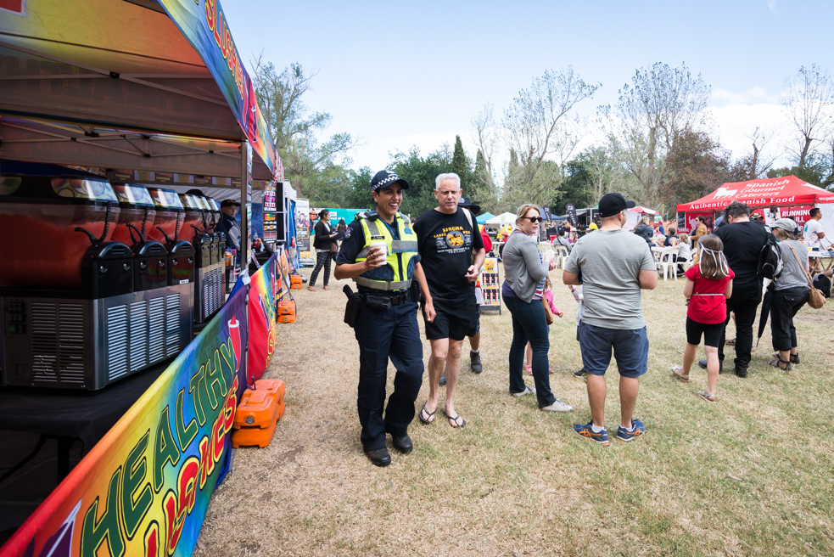At the festival I will see stalls….

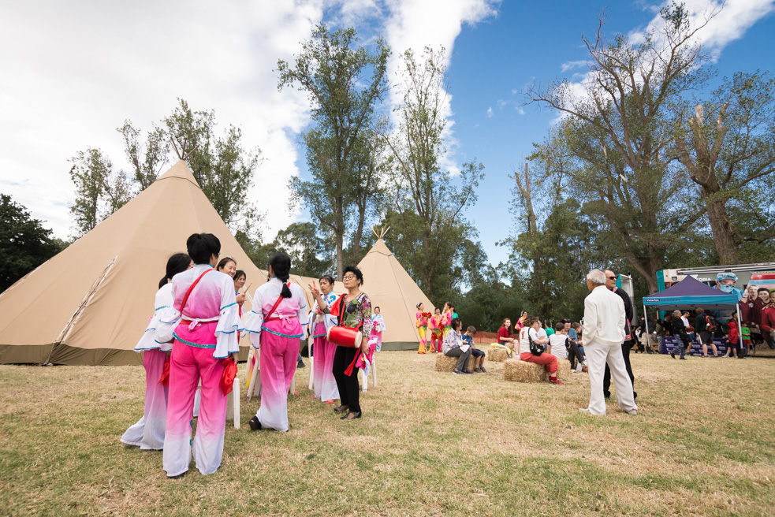

If I would like, there are activities I can do:
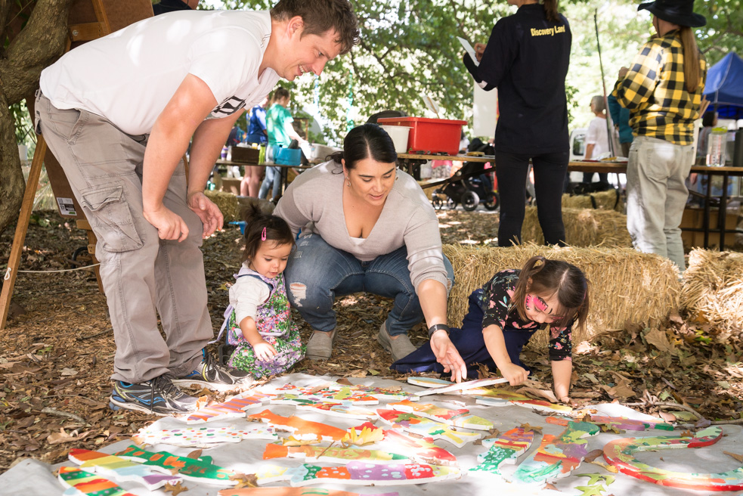

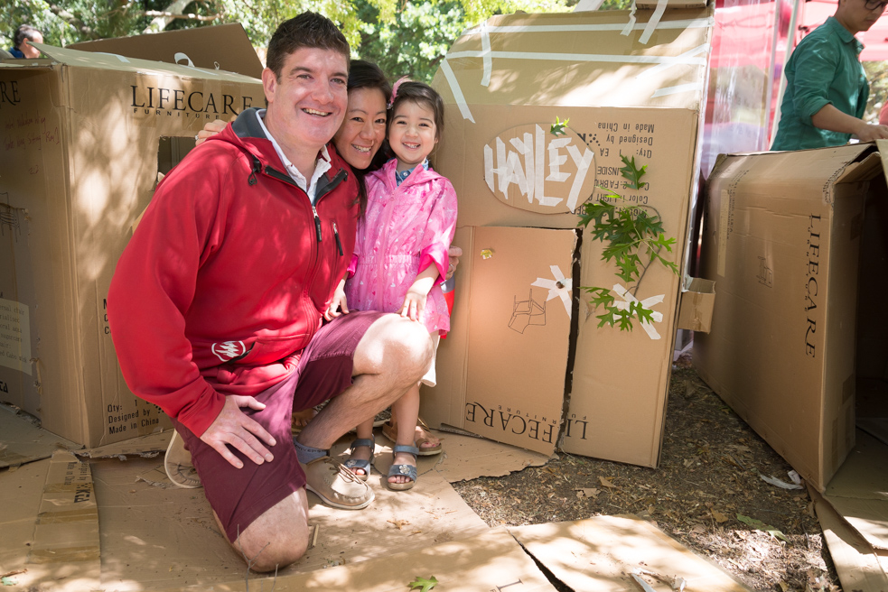

There will be music at the festival. If it gets too loud I can cover my ears or wear headphones. I can get headphones from the Customer Service tent, I just need to leave an ID card.
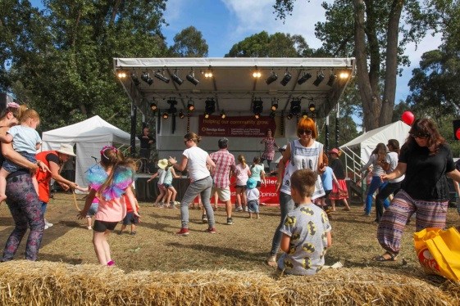
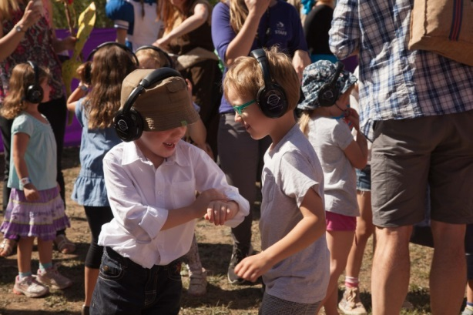
I can watch and listen to the music, dance or sing along.

There will be quiet and loud zones and I can choose which to go to by looking at site map.
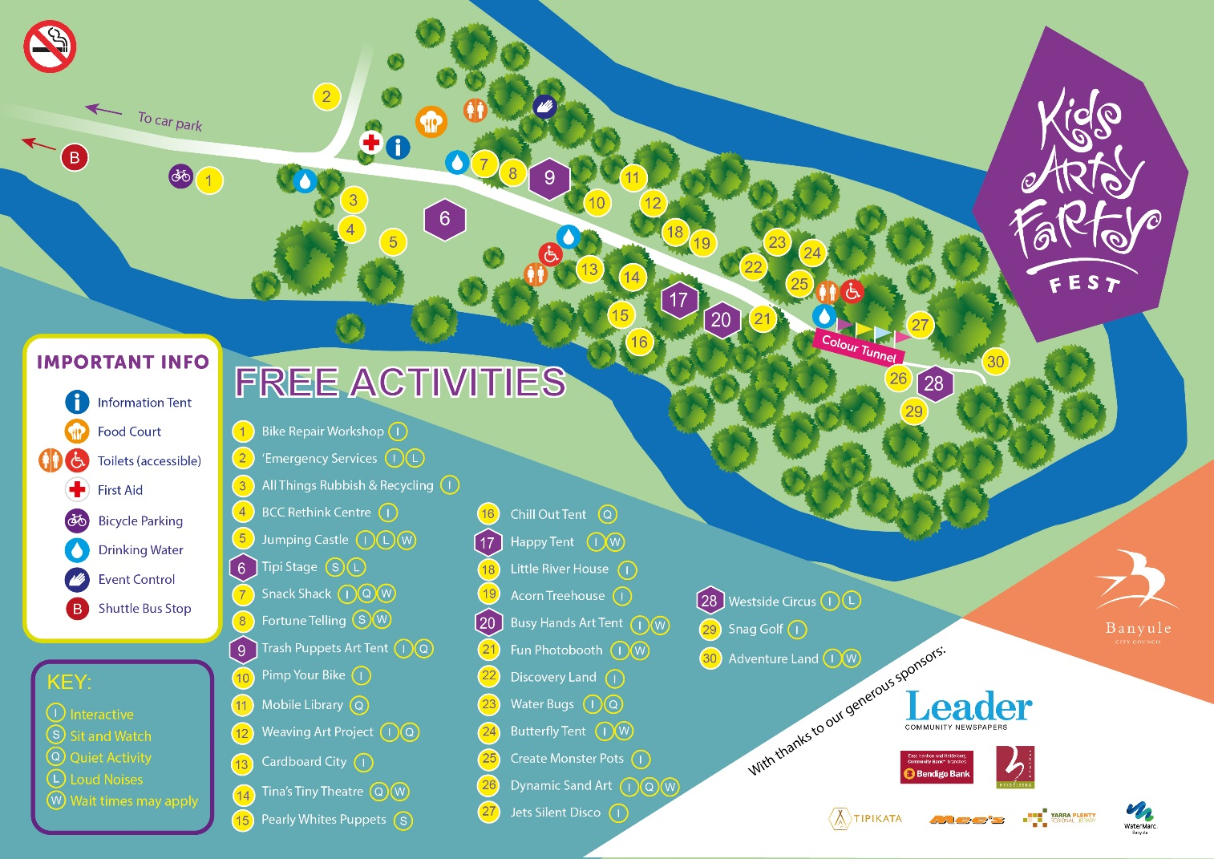

If I need to go to the toilet, I will let my family know and they’ll help me to follow the map.
There will be a lot of people at Sills Bend, to see the festival too. I will need to stay close to my family/carer.
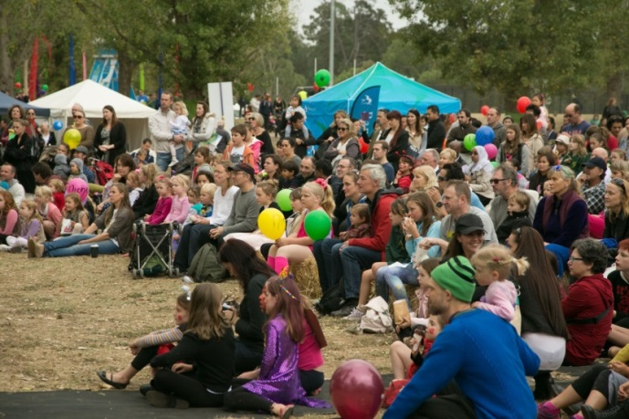

If I am allowed and I bring money, I can get food at the festival from a stall.

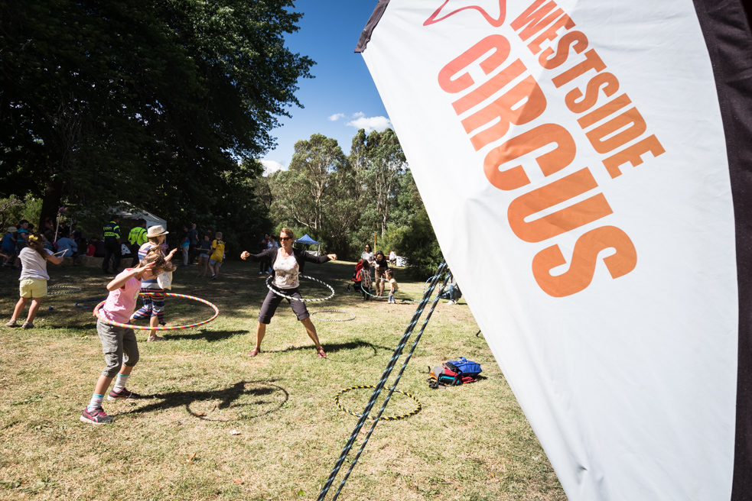If I need to run around, I can ask my family to take me to the oval or to a fun activity.

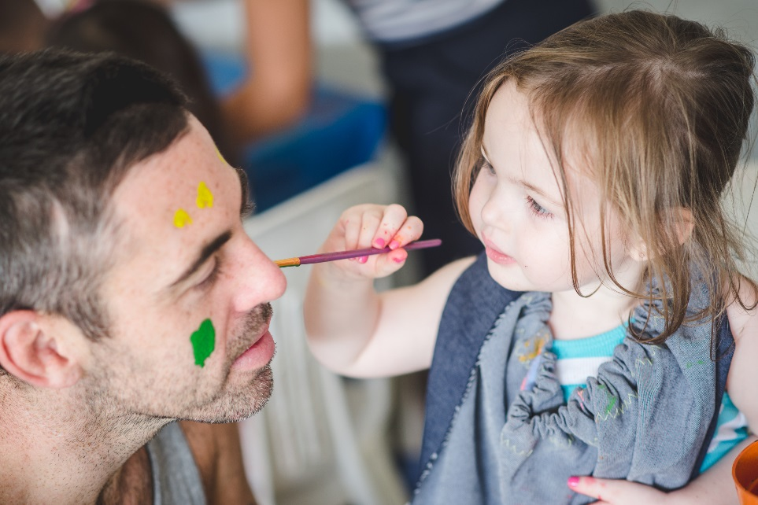
I can do heaps of free stuff there, like get my face painted, get photos and creative things!

If I need to have a rest, I can go in the chill out tent under the trees.
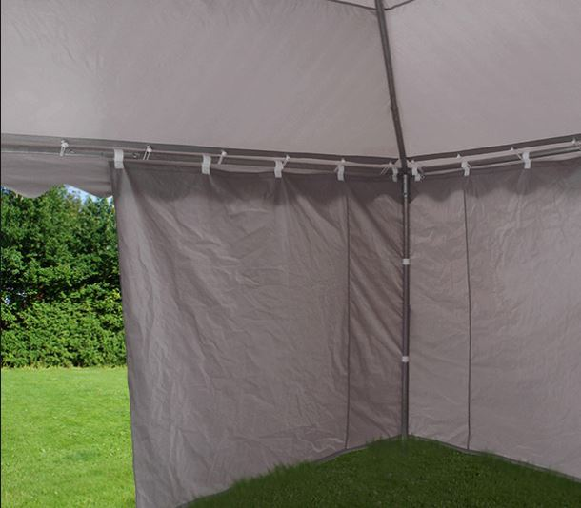

If I need help, I can see a staff member. They will be wearing a blue or grey shirt and hat.

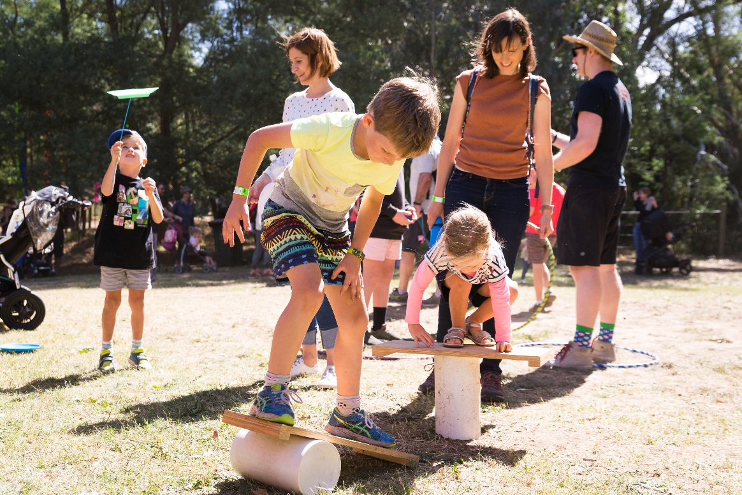
Going to Kids ArtyFarty Fest will be super fun!

Some things to remember:
It will be sunny/ hot: bring a sunhat and sunscreen
Or
It could be chilly, bring a jumper
If you need a straw to drink, bring your own….
The festival will be straw free
BYO water bottle
The park where the festival is has
Grass/concrete/pebbles etc… wear sensible shoes
Either eat before you come
Or bring money to buy food
Treat other festival goers with respect,
And they will do the same to you
Protect your hearing,
Ask for hearing protection at Customer Service (look at map)
Smoking, drug and alcohol free

